Department of Treasury Request for Proposal Response

Solicitation # 2032H323R00065

On-Demand Executive Coaching with Assessments &

Leadership Development Resources

Volume II: Technical Approach

Submitted By:

Company Name: **Sagely, LLC**

Address: **320 South Main Street Providence, RI**

DUNS: **075888104**

Point of Contact: Mandy Graham

Phone Number: 781.626.2797

Email: [mandy@growsagely.com](mailto:mandy@growsagely.com)

SUBMITTED TO:

Mr. Aaron C. Hill & Ms. Angela Gallo

5000 ELLIN ROAD

Lanham MD 20706

**August 31, 2023**

*This response includes data that must not be disclosed outside the Government and must not be duplicated, used or disclosed in whole or in part for any purposes other than to evaluate this response. If, however a contract is awarded to this Offer as a result of or in connection with the submission of this data the Government must have the right to duplicate use or disclose data to the extent provided in the resulting contract. This restriction does not limit the Government’s right to use information contained in this data if it’s obtained from another source without restriction. The data subject to this restriction is contained in this response.*

# Table of Contents

**Table of Contents 1**

**Glossary of Abbreviations 2**

1.0 Background 3

2.0 Technical Approach 3

2.1 Our Team 3

2.2 Sagely Coaching [SOW 3.1-3.5] 3

2.2.1 Sagely Platform [SOW 3.1] 4

2.2.2 Executive Coaching [SOW 3.1-3.3] 5

2.2.3 Engagement Preparation [SOW 3.2] 6

2.2.4 360 Assessments [SOW 3.5] 7

# 

##### 

# 

# 

# 

# 

# 

# 

# Glossary of Abbreviations

| **Acronym / Abbreviation** | **Definition** |
| --- | --- |
| AI | Artificial Intelligence |
| COTS | Commercial Off the Shelf |
| ECQ | Executive Core Qualification |
| ICF | International Coach Federation |
| KSAAs | Knowledge, Skills, Attitudes, and Actions |
| OPM | U.S. Office of Personnel Management |
| OUSD(A&S) | Office of the Undersecretary of Acquisition and Sustainment |
| RFP | Request for Proposal |
| SOW | Statement of Work |
| TEI | Treasury Executive Institute |
| Treasury | U.S. Department of Treasury |

# 

# 1.0 Background

The U.S. Department of Treasury (Treasury), Treasury Executive Institute (TEI) is on the forefront of integrating coaching into the federal Government. As the Request for Proposal (RFP) outlines, a web-based application that provides a platform for on-demand professional coaching in alignment, cognitive agility, and managing teams will further equip leaders to maximize performance and engagement.

# 2.0 Technical Approach

**Sagely provides tailored, scalable, technology-enabled coaching for organizations across all industries.** We specialize in upskilling for teams, bringing together the latest in coaching theory, habit-building science, and adult skill acquisition to maximize engagement, all underpinned by the Sagely platform.

We believe in coaching because we have experienced the benefits directly, reinforcing the statistics: **88% increase in productivity with coaching plus training versus 22% increase for training alone.**[1] We aim to unleash the power of coaching and to take the guesswork out of employee development.

## 2.1 Our Team

Sagely is a Veteran-owned small business consisting of team members who have dedicated their careers to coaching people and teams to maximize organizational effectiveness. Our team includes a strong mix of educational, technical, and business talent, all aligned with the vision of being the world’s most trusted guide to personal and professional growth.

We have an unmatched cadre of ICF-certified coaches, including former Government executives. Our first-hand Government experience creates an incredible opportunity for empathy and drives the effectiveness of our executive coaching engagements. Our coaches specialize in experiential and transformational learning using leadership coaching to empower personal development.

## 2.2 Sagely Coaching [SOW 3.1-3.5]

Sagely believes there is no replacement for skilled, credible human-to-human coaching to improve performance. Still, a post-COVID, distributed world requires adaptation to meet the sustainability, affordability, and scale that larger companies and Government organizations require. **Sagely brings to market an innovative approach to scaling effective coaching across organizations.**

The U.S. Office of Personnel Management (OPM) sets the stage: “Coaching is one of the most valuable development resources we can offer our workforce and has been linked to positive outcomes such as increased productivity, retention, and engagement.”[2]

Our coaching management and learning experience platform delivers a technology-forward way to organize and support on-demand coaching throughout TEI. We lower the cognitive burden of employee development by using Artificial Intelligence (AI) and automation to personalize the upskilling process for each employee. The platform navigates individual learning styles, tracks upskilling and reskilling needs, and provides a top-level dashboard of your team’s progress and needs to support your coaching and development process. Our platform provides learners with dynamic curriculums pulled from the latest industry thought leaders, best practices, tutorials, workshops, etc., with the support of our recommendation engine, which allows coaches to spend their time with the coachee, rather than manually curating material. The result is personalized, scalable, and technology-enabled coaching informed by adult learning science to drive outcomes. The Sagely platform provides communication with coaches, and access to our curated digital libraries **24 hours a day, 7 days a week.** When necessary, **customer support** is available via email with responses within one (1) business day [SOW 3.0].

### 2.2.1 Sagely Platform [SOW 3.1]

Sagely’s on-demand coaching platform is a critical enabler to scale and insight, designed with the needs of our customers in mind. Sagely provides an easy-to-use platform that is available to all web and mobile users, and is compliant with Section 508 accessibility guidelines, ensuring a rich and consistent experience for all users.

The Sagely Platform is the **single stop for the whole team**–individual coachees, coaches, leaders, and administrators. The platform includes scheduling, coach matching, assessments, a team-wide dashboard, and the resource portal. We provide the opportunity to tailor the platform to suit TEI’s needs, the ability to create or curate your organizational library, and offer a framework, expertise and tools necessary to maximize your internal coaching practice without the need for an army of consultants. **At the request of the Government, Sagely will provide platform demos to orient new coachees**. [SOW 3.1].

Each coachee can [SOW 3.1]:

* Search through Sagely's coaching catalog and select a coach based on specific coaching philosophies, backgrounds, and experience of our **ICF-certified coaches** [SOW 3.4];
* Schedule **on-demand, virtual 1:1 coaching sessions, for 30-60 minutes** with their coach within one business day, with out-of-the-box integrations to their calendar (i.e. Outlook);
* Have **24/7 on-demand access to learning/development resources** through our curated resource libraries, coaches, and (optionally) their organization (**Figure 1**).

|  |
| --- |
| **Figure 1**: 24/7 On-Demand Access to Curated Learning/Development Resources |

* When granted the administrator role, users can access the **real-time monitoring and usage dashboard** to gain valuable insights, including [SOW 3.1]:
* Aggregated data for coachee engagement and progression in the platform;
* Coachee and coach feedback on coaching engagements and resources;
* Coaching sessions conducted through the platform and topics covered.

**Reports for these metrics and more are generated on-demand** by Sagely or by organization administrators to snapshot historical usage. All coachees and coaches require a named license ("seat"). **Seats are purchased for a six (6) or 12-month duration at the Government's discretion**. Seats can also be purchased in bulk for a more cost-effective alternative. While Sagely strongly recommends a single individual maintain the license for the duration to maximize the benefits of the coaching relationship and individualized learning, we understand that is not always possible and offer **the ability to transfer seats as long as more than four (4) months remain on that license** [SOW 3.1].

|  |
| --- |
| **Figure 2**: Kolb’s Experiential Learning Theory |

### 2.2.2 Executive Coaching [SOW 3.1-3.3]

Sagely’s executive coaching philosophy is rooted in our proprietary Sagely Learning Model, which addresses the full spectrum of learning: theoretical knowledge, experiential learning, and real-world application. To enable this, we identify learning and coaching preferences for every coachee during their onboarding to the platform. Over the life of the coaching engagement, we monitor how each learning strategy is applied by their coach to ensure balance, and apply specific practices for each (i.e. Kolb’s Experiential Learning Theory, **Figure 2**).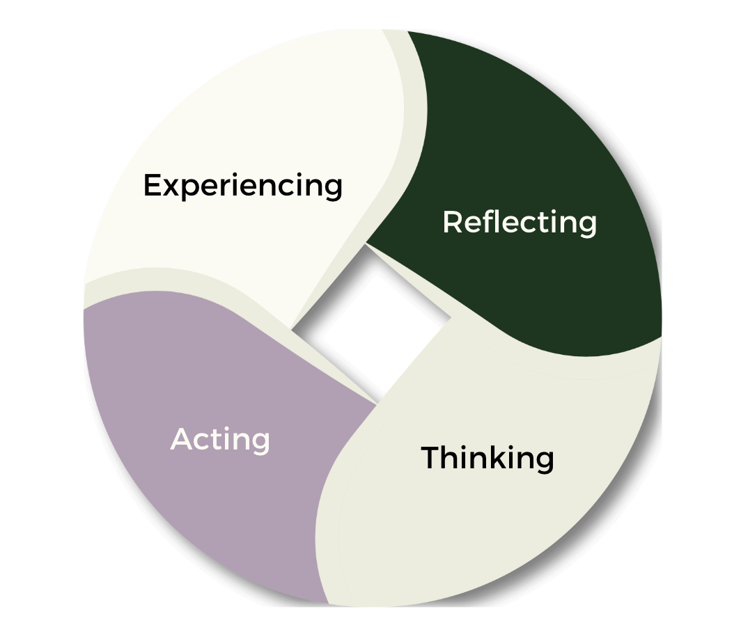

Everyone is different, and it follows that everyone learns and leads differently. Sagely believes in the **whole-person approach** measuring both mindsets and behaviors, and facilitating comprehensive growth in both, we break down each domain (i.e. Executive Leadership) into measurable subdomains (i.e. Leading Change, Leading People, Results Driven, Business Acumen, and Building Coalitions). Within each of these subdomains, our coaches work with their coachees to improve Knowledge, Skills, Attitudes, and Actions (KSAAs). This approach ensures we meet each coachee where they are and provide a highly individualized and unique coaching experience for everyone - building on each individual’s strengths with an experience that brings consistent and measurable growth (**Figure 3**).

|  |
| --- |
| **Figure 3**: Measuring KSAAs per Subdomain |

### 2.2.3 Engagement Preparation [SOW 3.2]

A productive coaching relationship relies on understanding learning and coaching preferences to match people with similar styles, and aligning on a coaching agreement. To kickstart this relationship, every engagement between a new learner and their coach begins with:

*1. A thorough onboarding process -* The coachee receives log-in access to the Sagely platform. Within the web-based application, the coachee answers questions to help discern **more about them as an individual and their areas of support and development**. These initial questions baseline the coachee and establish their profile: coaching preferences, time availability, communication strengths, and more. Onboardingalso outlines the coaching process, outcomes, and other logistical considerations to orient the coachee. During this stage, the coachee uses the platform to immediately request an ICF-certified executive coach; the Sagely platform provides recommended coaches based on learning preferences and goals. **The coachee can then schedule an introductory discussion with their selected coach at their discretion** (as quickly as that same day if both are available).

*2. An introductory discussion to assess fit between the designated coach and coachee* - Once the coach confirms, the platform adds the coaching session to the Outlook calendars of both participants. **During the introductory session**, coach and coachee review the coachee’s onboarding information and align on high level goals for the relationship. It is vital to find a fit between all parties. If, for any reason, over time, a coaching relationship does not prove to be compatible, the coachee has the option to identify an alternative coach.

*3. Development of a coaching plan to achieve desired outcomes -* While our learning curriculums tend to be dynamic based on coachee needs, we start with a high-level scaffolding to ensure common understanding of their goals and organizational needs. **The first two sessions inform the coaching plan**. The second session walks coachees through an initial assessment. The coach and coachee complete the assessment together, allowing the coach to quickly internalize coachee needs to create customized deliverables and developmental objectives within the individualized coaching plan.

### 2.2.4 360 Assessments [SOW 3.5]

Once the initial assessment has been completed as a baseline, the Sagely platform automatically prompts coaches to conduct a new assessment every quarter (or 90 days) to consistently measure growth across the KSAAs. The coach provides feedback for the subdomains in each assessment to help set goals and target specific growth areas for the following quarter (**Figure 4**).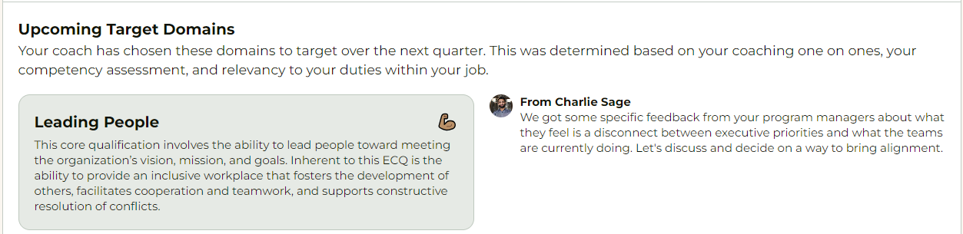

|  |
| --- |
| **Figure 4**: 360 Assessment Feedback Per Subdomain |

The same assessment is conducted **online within the Sagely platform by at least 3 of the coachee’s colleagues, direct reports, and managers to gain a complete picture of performance and effectiveness**. Feedback is anonymized and included in the 360 Assessment Summary, available to both the coachee and coach, with **supporting documentation attesting to the face validity, content validity, and reliability according to Cronbach’s Alpha** [SOW 3.5].[3] Coaches use this to update the individualized coaching plan including developmental recommendations mapped to the organization’s leadership competencies to address behavior change.

Our existing assessment philosophy of measuring competency across KSAAs builds on the methodology used in the OPM Leadership 360, and addresses the whole-person approach in a unique way to measure growth more accurately. The domains, subdomains, and competencies are all also 100% customizable. Sagely provides templated competency maps, curricula, learning resources, and assessments for a variety of domains which can be tailored to meet the needs of any specific organization, and to grow with you as you and your needs evolve.

1. Matuson, Roberta. “Is Executive Coaching Really Worth the Money?” Forbes, Forbes Magazine, 31 July 2023, www.forbes.com/sites/robertamatuson/2023/07/27/is-executive-coaching-really-worth-the-money/.
2. Chief Human Capital Officers Council. (2018, September 10). *Coaching in the federal government.* U.S. Office of Personnel Management. <https://chcoc.gov/content/coaching-federal-government>
3. <https://library.virginia.edu/data/articles/using-and-interpreting-cronbachs-alpha>